Name : Muhammad Redzuan Bin Parsikun
Matrix. No : 03DDT21F1005
Date : 18/4/2023 (Tuesday)
Title : SimpleTextEditor / Import Module tkinter

1. Coding
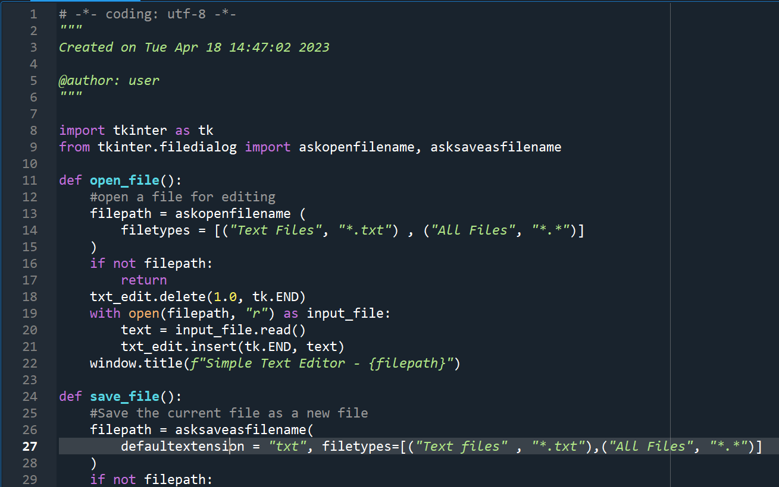
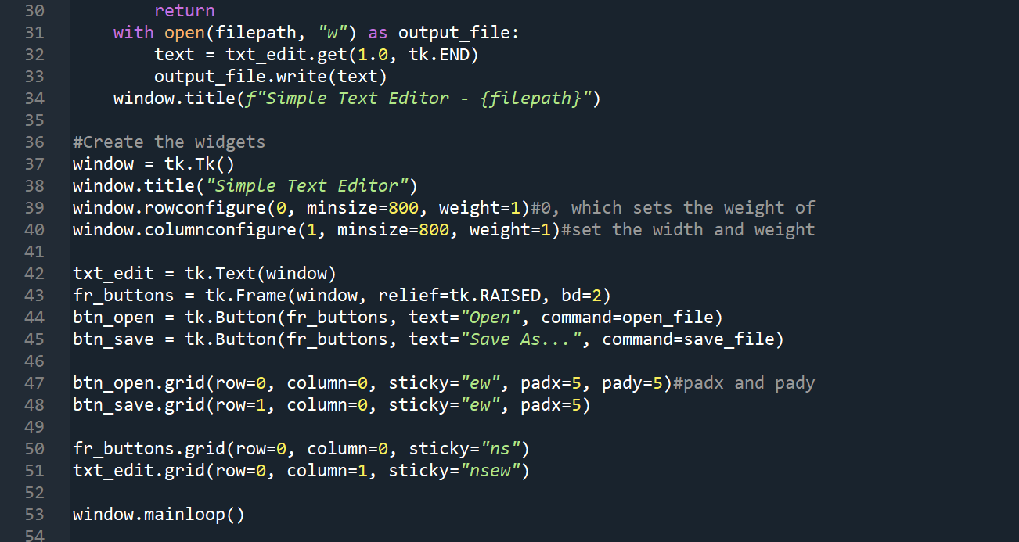

2. Output
Write or Read After Save As
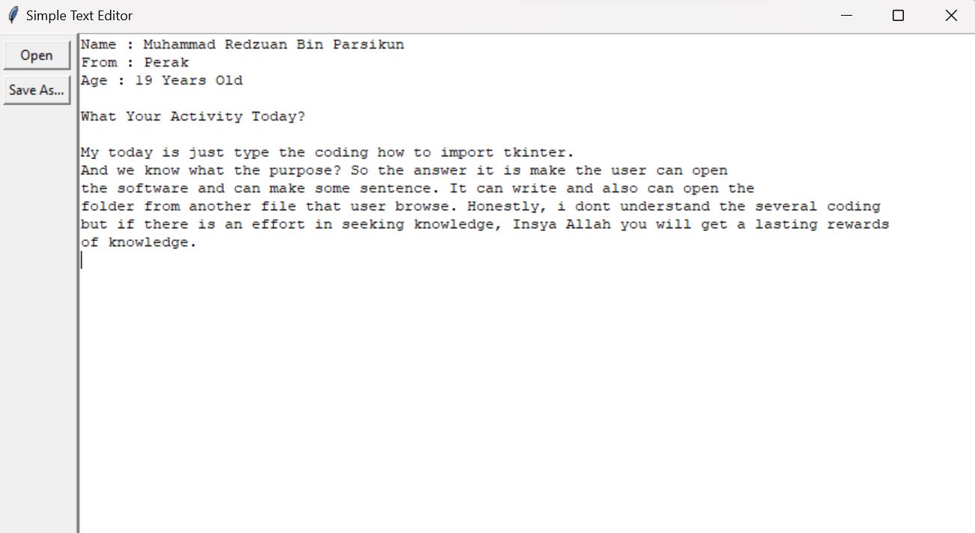
Read after Save As “YourActivity.txt” and open at Notepad
